Funding Announcement
ACLPS is now accepting applications for the

ACLPS Paul E. Strandjord Young Investigator Grants
The Paul E. Strandjord Young Investigator
Grants are for research relevant to clinical
clinical pathology, and laboratory science,
laboratory medicine. Proposed research may be clinical, translational, basic science, quality improvement, and/or regulatory.
Grant recipients must either be in training
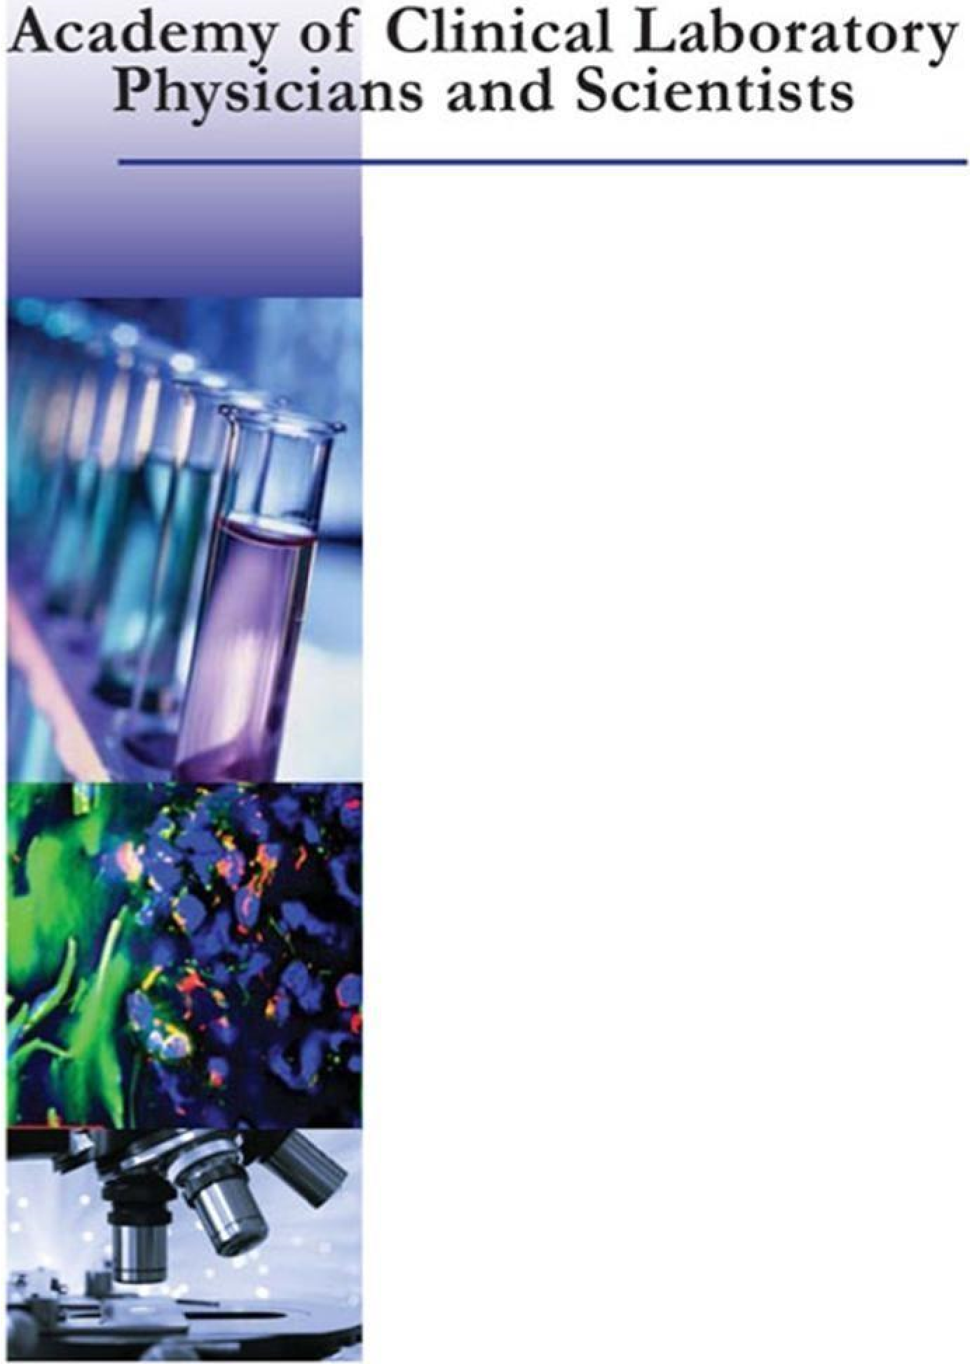
(residency and/or clinical or research fellowship) OR less than 3 years after their faculty first appointment (any level) at the time of application.
For more information and application instructions, please visit the ACLPS website
https://www.aclps.org/training-grants
Application Deadline: December 15, 2023

